City Administration

Report

June 11, 2024

This report is intended to provide Council with an overview of current activities, project status updates and previews of select upcoming issues and activities of Council and Staff.

Featured Items

1. **Pavilion Park Improvements – Phase I**

Improvements in phase I include all primary utilities including septic tank, water and waste service lines and new electrical systems. The pre-cast, two room restroom building was installed and connected and will be open to the public by the July 4th holiday weekend after required temporary ADA pathway surfaces are installed.

Phase II will go out to bid in late July, with Council bid award and construction beginning in late September or early October and will be complete by February of 2025. Phase II improvements include extension of irrigation systems, installation of ADA parking space and permanent paved pathways throughout the park, installation of new grading/mounding, vegetation and tree plantings and lighting along pathways.

1. **Premier RV Water Connection Project**

Branch Engineering and City staff have been working for well over a year completing required wetland permitting that included the purchase of $30,000 of wetland credits to allow construction work to install a three-inch service line connection to Premier RV. The permitting work also provides regulatory approvals necessary for waterline construction and eventual service connections to the recently annexed 107-acre light industrial property to the east of the Premier RV site, which is expected to begin construction by this fall for the initial waterline traversing from south to north along the west boundary of the 107-acre parcel.

1. **Public Works Operations Building**

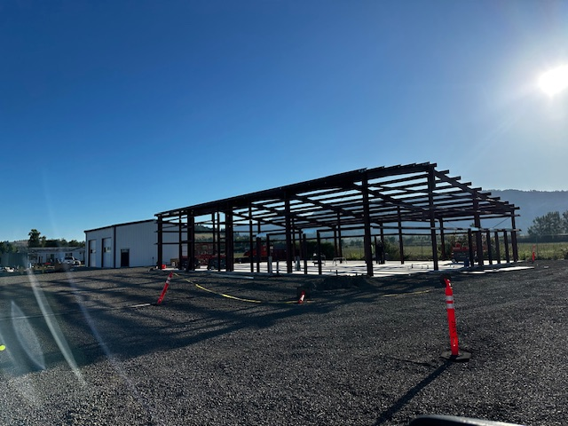The work at the new Public Works Operations Buildings at the City’s Wastewater Treatment Plant property have been moving forward at a steady pace with the smaller building that will be leased to Coburg Fire District for 10 years recently received its exterior shell and the main operations building completed the steel framing portion of the build out. Staff is anticipating a completion date in early to mid-September.

1. **July Council Work Session – Water System**

As discussed earlier in the year, staff is preparing materials for a Water System Council Work Session on July 23, 2024. Topics include a report and discussion of the water system capacity analysis recently completed by Consor, an update on the water project loan balance, water projects status updates and remaining projects we hope to be able to complete with the remaining loan funds, as well as the expected amount and timing for the upcoming loan debt service payments.

1. **City Cell Phone Upgrades**

With assistance from the IT services staff at Lane Council of Governments (LCOG), the City recently upgraded the outdated cell phone inventory and switched carriers from Verizon to AT&T. While AT&T monthly rates are likely to be less expensive than the current Verizon contract, a significant reason for moving carriers is the federal FirstNet public safety program that is exclusively offered by AT&T. FirstNet assures public safety and first responders priority bandwidth in emergencies, as well as provides a number of temporary emergency communications equipment access.

The phone upgrade also improved phone/data security and tracking to ensure required public safety CJIS and LEDS security protocols are met.

1. **Vegetation Management and Maintenance Plan**

Public Works staff has begun early planning and development work on an updated comprehensive Vegetation Management and Maintenance Plan. This plan is called out as one of the four objectives in the “Our Natural Resources” section of the Council adopted Framework document. The plan will include basic operational items such as grass mowing schedules, weed eating vs. hand treat areas, (non or limited) use of pesticides, seasonal field mowing schedules and other similar operational planning to aid in staffing deployment as well as to provide Council and the community with an understanding of the service level objectives in the City’s maintenance plan.

Prior to its adoption, the plan will likely have several rounds of discussion and input from the Park and Tree Committee before coming forward to Council for final review and approval. Staff is setting a spring 2025 completion date for this plan and is being led by Public Works Director Brian Harmon.

Current Projects & Contracts

The two tables below provide a summary of active infrastructure projects and signed contracts/agreements

|  |  |  |  |
| --- | --- | --- | --- |
| Project Type | Description | Est Cost | Complete Date |
| Water | Well #3 – Wellhouse, treatment, SCADA | $850,000 | Dec 2024 |
| Water | Stallings Transmission Line | $1,500,000 | June 2025 |
| Water | System Capacity Analysis - Consor | $30,000 | July 2024 |
| Streets | N Willamette/Macy/Harrision Reconstruct | $800,000 | Sept 2024 |
| Sewer | System Capacity Analysis – Kennedy Jenks | $32,000 | July 2024 |
| PW | PW Operations Building | $1,350,000 | Sept 2024 |

|  |  |  |
| --- | --- | --- |
| Contract Description/Scope | Cost | Term |
| Lane Council of Governments – IT Services | $60,175 | 7/24 – 6/25 |
| Lane County Transportation – Special Events IGA | $0 | 7/24 – 6/27 |
| Coalition Insurance Solutions – Cyber Security Insurance | $8,088 | 7/24 – 6/25 |
|  |  |  |
|  |  |  |
|  |  |  |

Department Activity & Statistics

Staff maintains various activity, work order and case log type records that are utilized for a variety of required reporting to other agencies and/or for day-to-day oversight and management of their operations. Some of the data comes from third party software systems and typically not always in a format that is easily summarized or customized.

Public Works

|  |
| --- |
| **May Highlights** |
| Parks**:** |
| Three new trees planted at Norma Pheiffer Park along sidewalk between Harrison and Diamond Streets to match existing flowering cherry trees. |
| Streets: |
| Over 20 hours of staff time and three full days of contract work on right-of-way mowing |
| Water: |
| Six new meter services installed  Fleet:  Battery replacements for Police Department speed display/data trailer  Facilities:  HVAC system failure at City Hall caused smoke and temporary evacuation of City Hall. Contractor called in and determined equipment failure components. Repaired and operational ($1,500 GF expense) |

Planning

* SUB 02-20 & SUB 01-22: Coburg Creek Subdivision: Three new dwelling permits issued in April;
* 18 Structural/Plumbing/Mechanical/Electrical permits issued in April;
* Attended regional transportation meetings including Safe Lane Transportation Coalition, Metropolitan Planning Committee and Technical Advisory Sub-Committee (of MPC), Regional Transportation Plan (RTP) and Congestion Management Plan (CMP) update kickoff meeting, and was asked to participcate on the technical advisory committee for the walkability model code development for CFEC implementation to provide a small city perspective;
* Applied for RARE member to implement TMDL work and interviewed with RARE program director;
* Planning Commission granted the extension request for the Willamette Forks site review approval (SR 01-22). The approval expires September 10th, 2024 with no further extension requests available.

Municipal Court

*Comparisons should only be considered when viewing the year-to-date amounts as court dates are not consistently held on the same dates each month, nor is there consistent cases presented to the court****.***

*Other Information:*

* Upcoming Court Dates: Tuesday, June 4, 2024

Tuesday, July 16, 2024

* Received renewal contract for Springfield Municipal Jail. This will be a two-year contract
* Currently have 1 Jury trial scheduled this summer
* The Informal Solicitation process for the City Prosecutor contract ends May 31, 2024

Police

* Officers completed a death investigation.
* Officers arrested a male for a felony probation violation warrant.
* Officer located a DUII driver and Eugene Police Officers arrested the driver.
* Officer followed up on a DHS referral and provided a ride for the juvenile.
* Officer took a report for a stolen vehicle and determined it was a civil matter.
* Officer investigated a vicious dog complaint and determined both owners were at fault.
* Officers arrested a female for driving under the influence.
* Officer attempted to follow-up with a DHS referral but is waiting for DHS contact.
* Officer investigated several stolen vehicles and determined it was a civil matter.
* Officer located a missing person.
* Officer arrested a male for resisting arrest and disorderly conduct.
* Officer cited a male for a failure to appear warrant.
* Officer cited a male for contempt of court on a traffic stop.
* Officer investigated a possible child neglect and determined children were fine.
* Officer used the CHETT fund to purchase food for a male.
* Officer contacted a male at the park.
* Officer investigated a hit and run.
* Officers arrested a male for several misdemeanor warrants.
* Officer investigated a burglary by a former employee; case is pending suspect contact.
* Officer investigated criminal mischief at Norma Pfeiffer Park.
* Officer purchased fuel for a stranded motorist.
* Officer took a report for putting a commercial truck driver out of service.
* Officer cited a male for misdemeanor driving while suspended.
* Officer placed a female on a police officer hold and transported her to the hospital.
* Officer completed a sex offender registration for intended international travel.
* Officer arrested a male for a felony assault.
* Officers directed traffic and assisted multiple agencies on a critical incident.
* Officers participated in Community Shred Day.
* Officers participated in the DEA Drug Takeback.
* Officer attended CIT training from the FBI.
* Officers participated in a saturation patrol.
* Officers investigated a shooting and theft.
* Officers investigated an Assault IV (APA)
* Officers investigated an arrested a male for Criminal Mischief I and Criminal Trespass 2

**Upcoming Events:**

SFST training

City Recorder/UB

Staff is working to develop a set of performance measures and metrics to communicate the highly variable and very broad scope of the work done by the City Recorder and the front office Utility Billing team that supports the entire organization and operations of the City. As these metrics are developed, staff is committed to providing relevant information on individual programs and activities carried out by this team.

* No May metrics to report
* April metrics focused on Communications/Social Media